Women in LANL Computing Image Captions

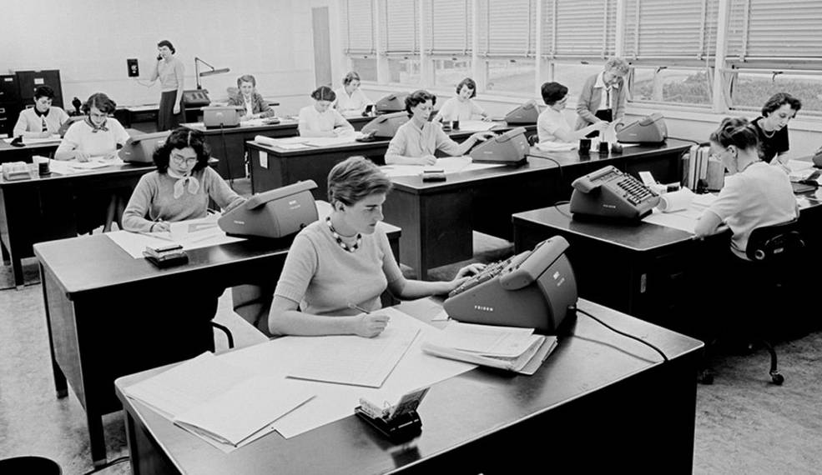

Title: Origins

Caption: NASA hand-computing group circa 1955 using Friden mechanical calculators in an operation similar to that at contemporaneous Los Alamos.

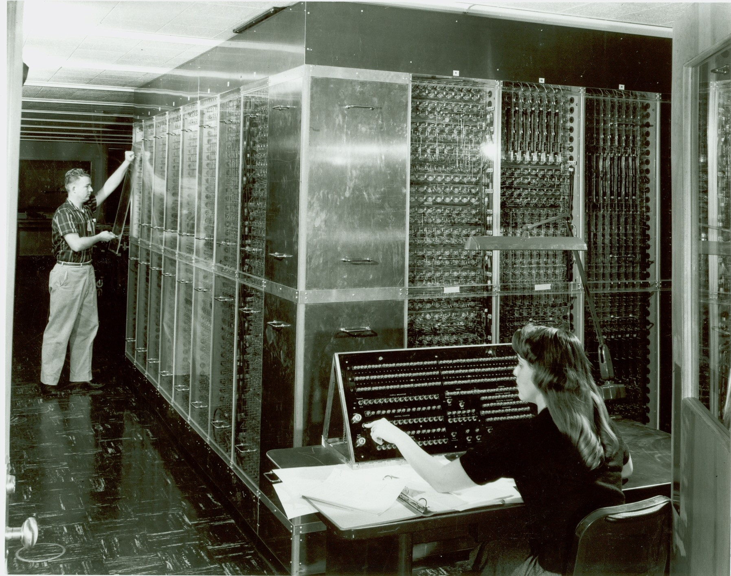

Title: Advancement

Caption: Operating the Los Alamos-built MANIAC II (1957).

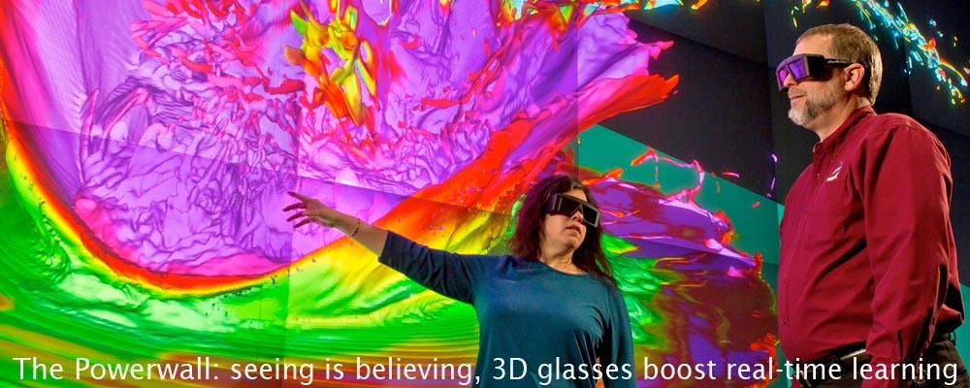

Title: Continuing Legacy

Caption: 3D visualization on the Powerwall.

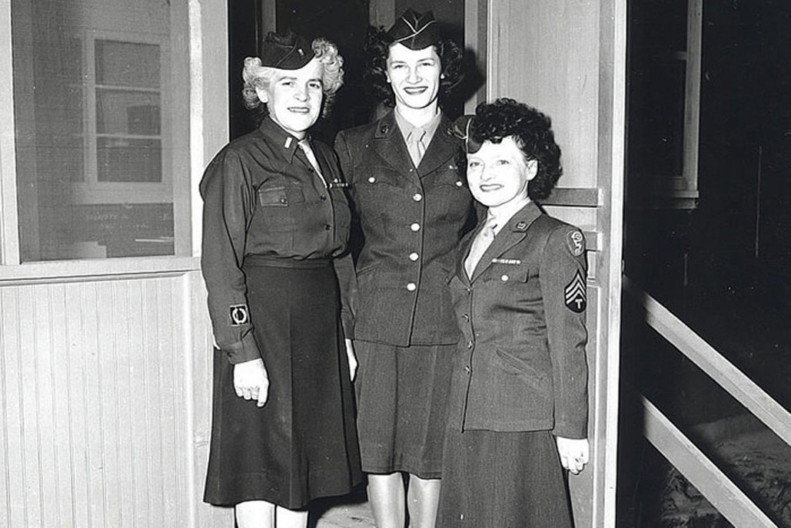

Caption: Members of the Women's Army Corps (WACs) at Manhattan Project Los Alamos.

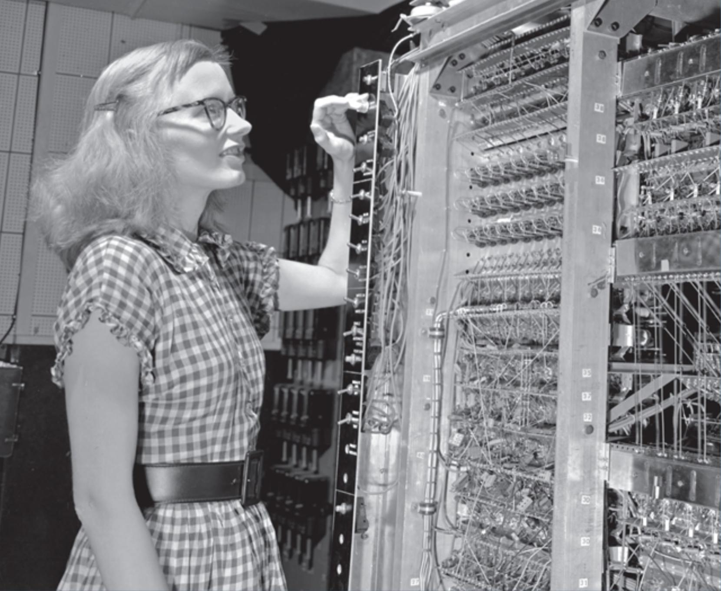

Caption: Lois Cook Leurgans, programmer and systems analyst of the MANIAC (1953).

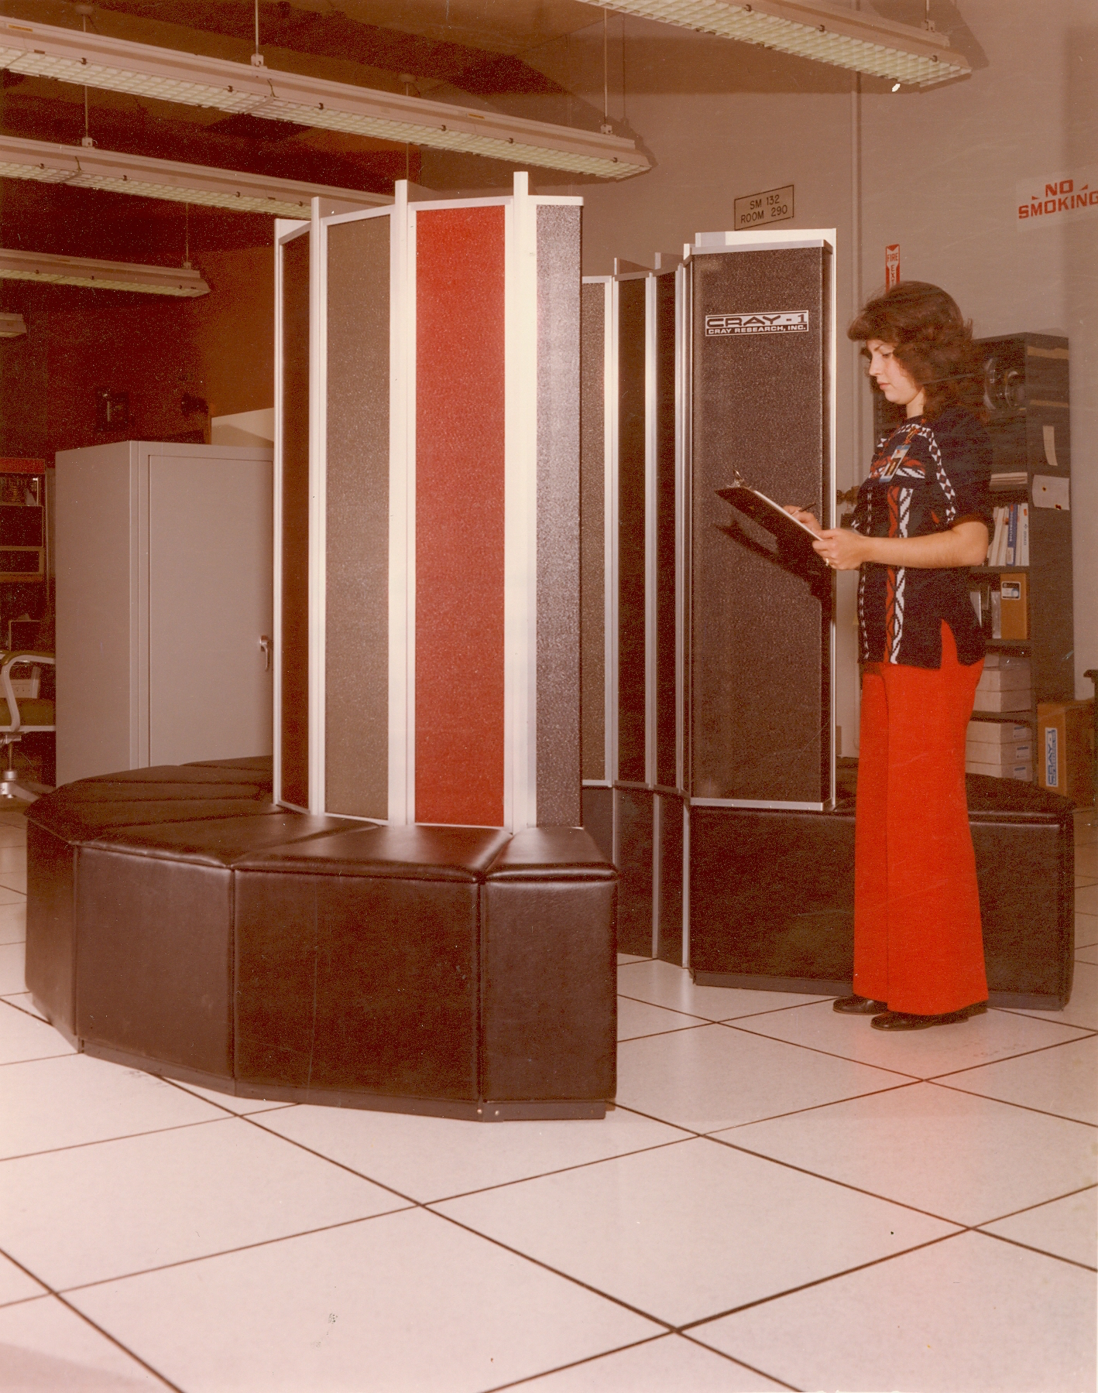

Caption: Veronica Atencio and the first Cray-1 supercomputer (1976).

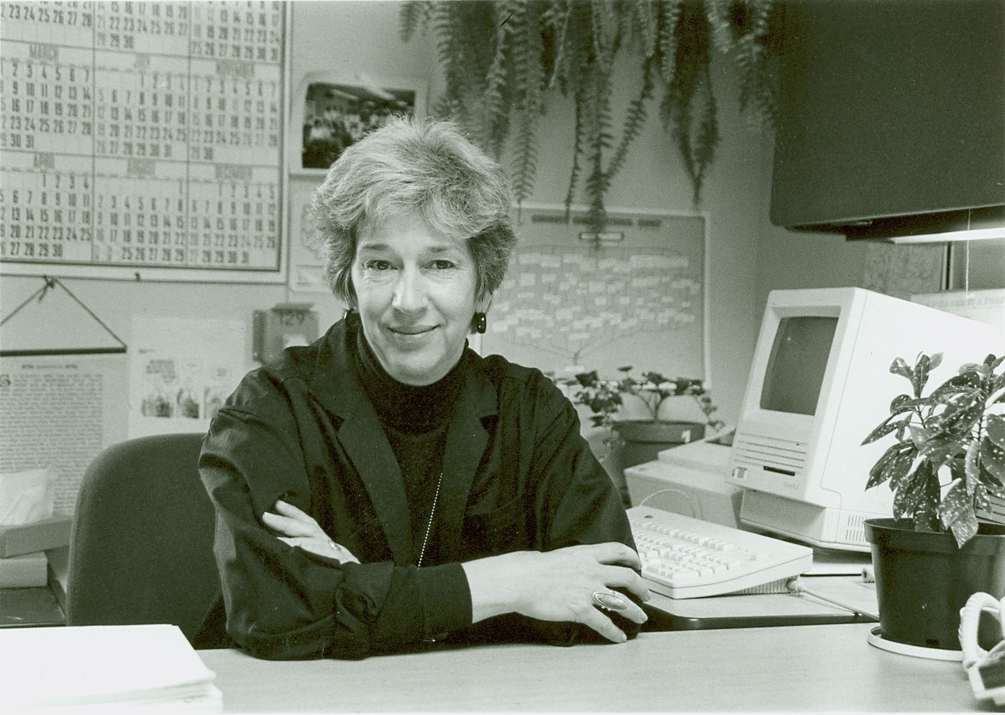

Caption: Ann Hayes, Executive Director of LANL's Advanced Computing Laboratory (1990).

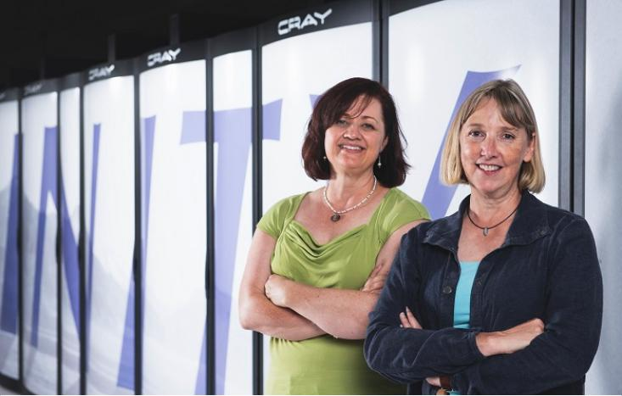

Caption: HPC-ENV group leader Cindy Martin and XCP code-team leader Joann Campbell (2016).